Clone github: <https://github.com/esp8266/Arduino>

Unzip. Go to folder “\Arduino-master\Arduino-master\libraries\” and copy and zip the folder “ESP8266WiFi” to your preferred location

Add the zipped library:

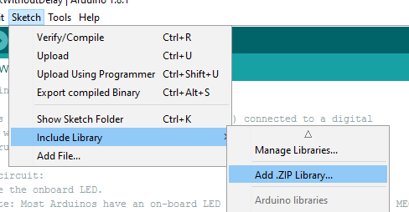

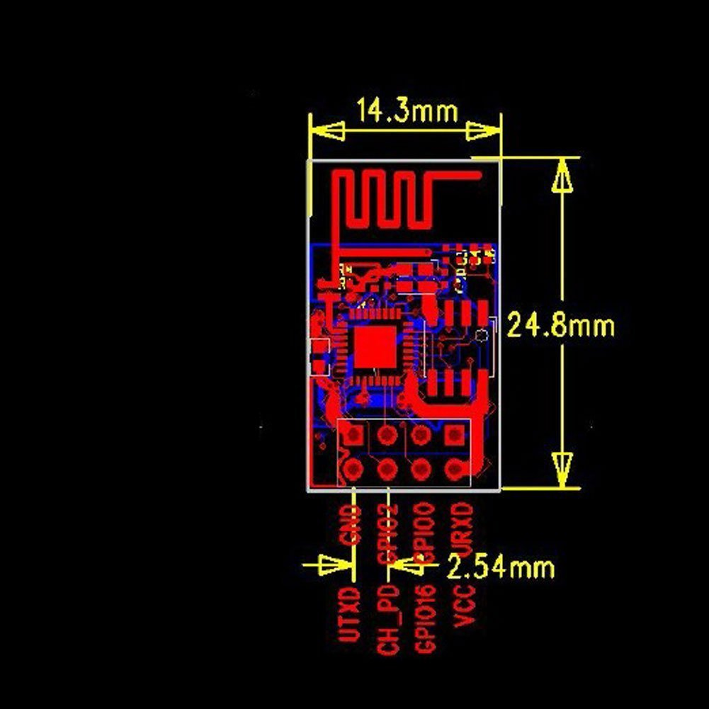

Pinout descriptions for different models

<http://www.esp8266.com/wiki/doku.php?id=esp8266-module-family#esp-01>

This section give schematics and how to set up (see images below)

<https://github.com/esp8266/Arduino/blob/master/doc/boards.md>

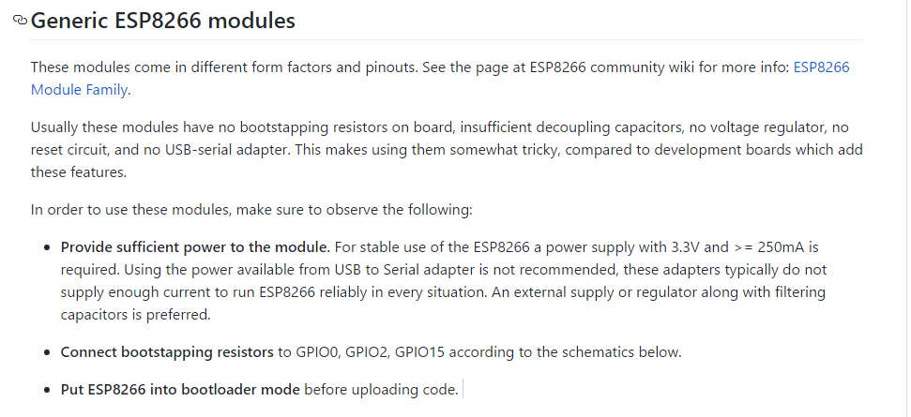

Set the FTDI232 USB converter to 3.3V!!!!

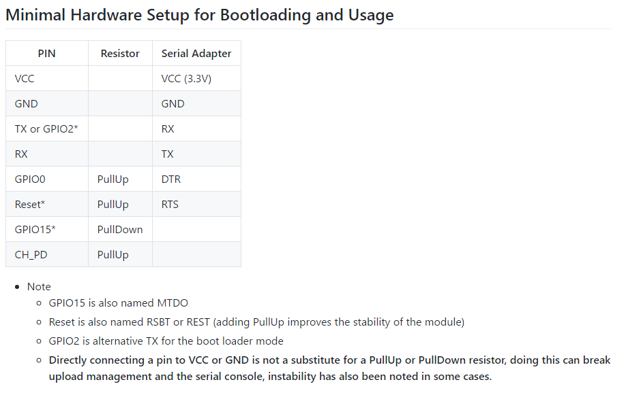

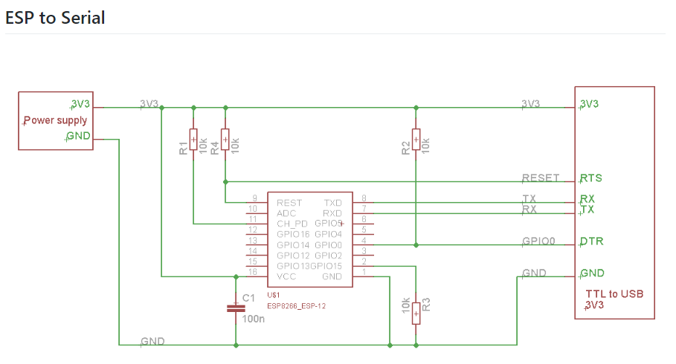

Then go here and here for example code:

<https://github.com/esp8266/Arduino/blob/master/doc/esp8266wifi/readme.md#soft-access-point>

<https://github.com/esp8266/Arduino/blob/master/doc/esp8266wifi/soft-access-point-class.md>